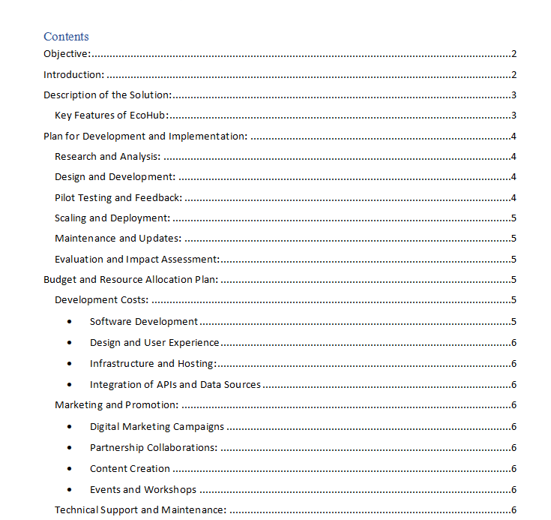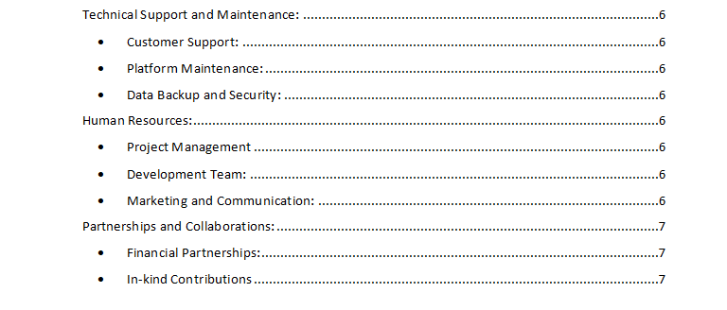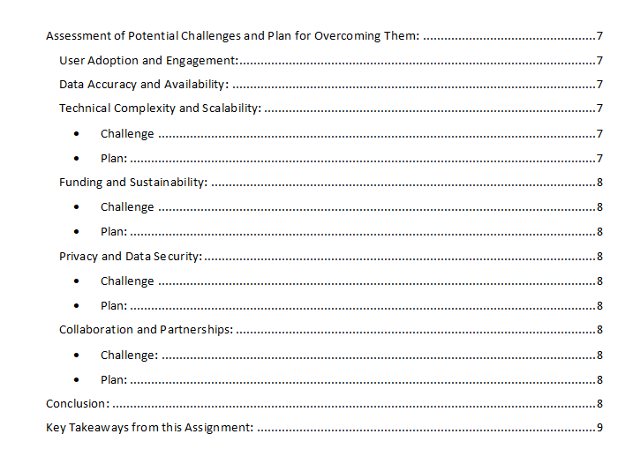

# 

# Objective:

The goal of our group project is to investigate how digital technology can help tackle the worldwide problem of climate change. We will pinpoint the precise climate change problem areas, investigate the available digital alternatives, and put forth a creative digital solution that can help mitigate climate change. This group project's goal is to investigate how digital technology may be used to address the urgent problem of climate change. We seek to go beyond only identifying the flaws in climate change and instead concentrate on developing cutting-edge, technologically advanced remedies. We may learn more about the effectiveness of the current digital climate change solutions and technology by researching them, as well as pinpoint areas that require more innovation. We want to suggest a digital solution through this project that can have a real, beneficial effect on reducing climate change. In order to improve the world for next generations, we want to foster innovative and critical thinking about how technology might be used to solve problems in the real world.

# Work distribution table:

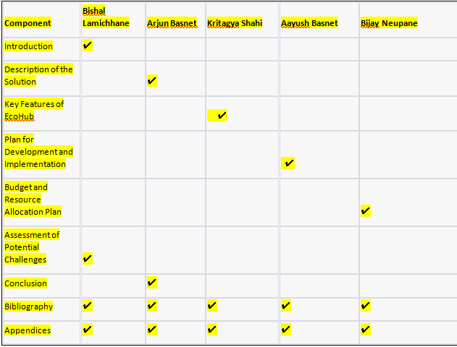

# Grantt Chart:

# digital (1).png

# gannt chart (1).png

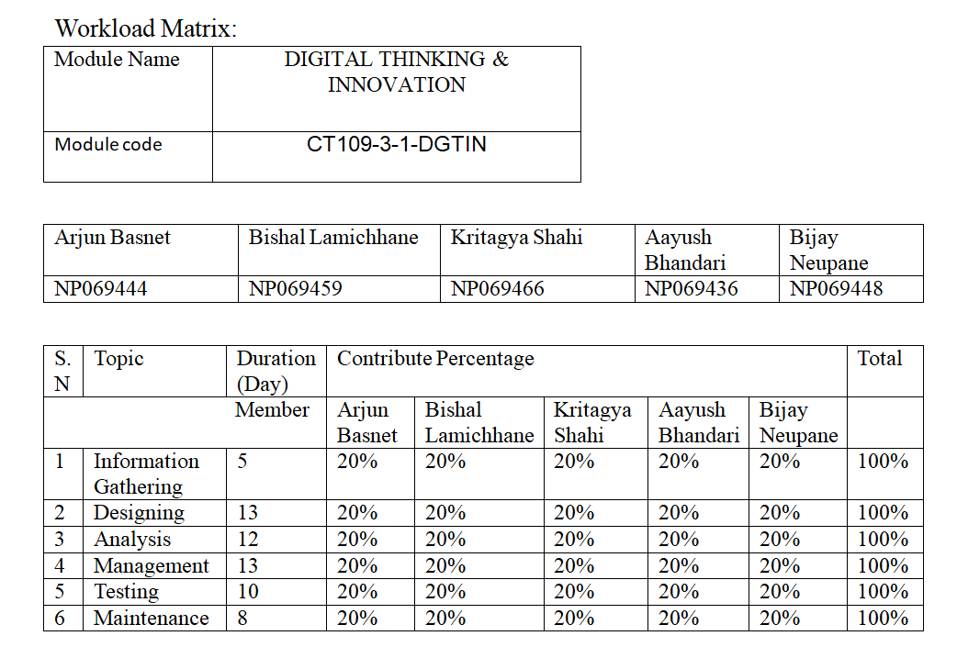

# Introduction:

One of the most important global issues of our day is climate change. It's a complicated problem that involves a variety of social, economic, and environmental aspects. Our climate system has seen extraordinary changes as a result of the worrisome increase in greenhouse gas emissions, which are mostly caused by human activity. Extreme weather, rising sea levels, and ecological disruptions are some of the effects of climate change that have a significant impact on both current and future generations. (Issues, 2010)

All facets of society must act quickly and collectively to combat climate change. Although some old ways have been successful, digital technology's potential to reduce climate change has not yet been fully realised. Digital solutions provide creative ways to track, control, and lower carbon emissions, encourage sustainable behaviours, and promote international cooperation. Our team wants to explore the world of digital climate change solutions in this assignment. We will examine the particular issues related to climate change, investigate current digital projects and technology, and suggest a creative digital solution that can help create a more sustainable and resilient future. Through our investigation, we seek to draw attention to the enormous potential of digital technology to address the problems caused by climate change and to spark original thought in the direction of creating a better environment for coming generations. (Jackson, 2023)

# IMG_20230815_212057.jpgDescription of the Solution:

The name of the digital solution we suggest is "EcoHub." EcoHub is a comprehensive platform that uses digital technologies to encourage sustainable behaviours and combat climate change. It acts as a focal point where people, groups, companies, and organisations can work together and use various tools and services to lessen their carbon footprint and contribute to a more sustainable future.

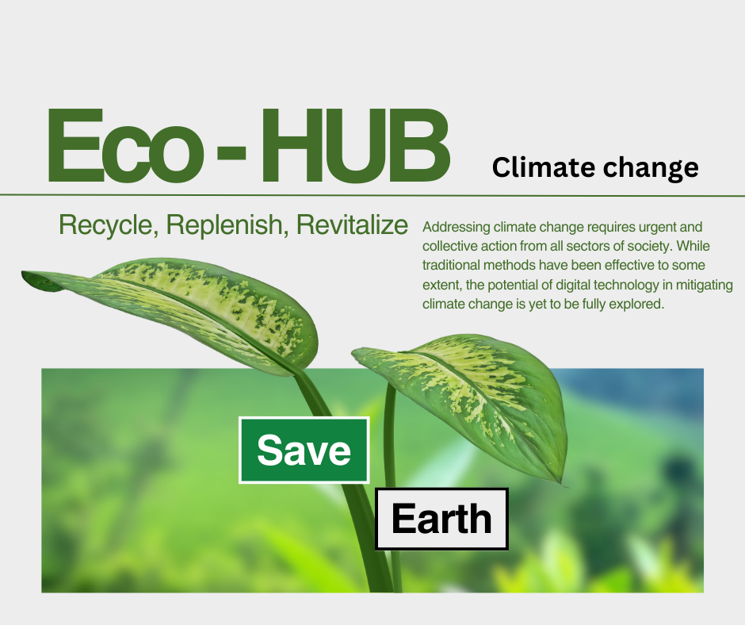

## Key Features of EcoHub:ecooo.png

1. Carbon Footprint Calculator: EcoHub features a user-friendly carbon footprint calculator that enables people and businesses to gauge and monitor their carbon emissions from many elements of their daily life or business operations. It provides a thorough understanding of carbon footprints by taking into account variables including energy usage, travel patterns, waste management, and purchase decisions..
2. Personalised Action Plans: Using the calculated carbon footprint, EcoHub creates personalised action plans that recommend doable activities for people and businesses to take in order to minimise their carbon emissions. These strategies consider the particular situation and offer specialised advice on trash reduction, eco-friendly purchasing, energy efficiency, and sustainable transportation solutions..
3. Community Collaboration and Engagement: EcoHub builds a thriving and encouraging community for climate action. Users can interact with people who share their interests, join groups that are concerned with sustainability, and take part in cooperative projects. The platform promotes group accountability and cooperative action by facilitating knowledge sharing, discussion forums, and the exchange of best practises.
4. Resource Library: EcoHub has an extensive resource library that gives users access to a variety of learning resources, academic articles, case studies, and creative responses to climate change and sustainability. The library functions as a useful knowledge base, providing users with the data they need to make wise decisions and promote change.
5. Gamification and Rewards: EcoHub uses gamification components to encourage sustainable behaviours. For reaching sustainability milestones, taking part in challenges, and implementing sustainable practises, users can accumulate points, badges, or virtual rewards. Users are further encouraged to take action by the fact that these incentives can be exchanged for discounts, eco-friendly goods, or donations to environmental charities.
6. Data Analytics and Visualisation: To give consumers insightful information about their environmental effect, EcoHub makes use of cutting-edge data analytics and visualisation tools. It enables users to analyse the overall effects of the community's actions, track progress over time, and pinpoint areas for improvement. Data-driven visualisations help people grasp complicated information simply and motivate them to take part actively in sustainable practises.

# Plan for Development and Implementation:

## We have created a thorough strategy that specifies the essential procedures and factors in order to guarantee the effective development and execution of EcoHub. The following phases are included in the plan: (Asana, 2020)

## Research and Analysis:

* + Conduct in-depth research on current digital platforms and solutions for sustainability and climate change.
  + Examine user preferences and needs to comprehend the intended market and adjust EcoHub's features.
  + Identify potential collaboration and support relationships with businesses, academic institutions, and environmental organisations.

## Design and Development:

* + - Work with developers and designers to produce an EcoHub interface that is simple to use and visually appealing.
    - Create databases and backend architecture to provide platform functionality while guaranteeing scalability and security.
    - Include in the platform the resource library, personalised action plans, community interaction tools, and carbon footprint calculator.
    - Use gamification components, incentive programmes, and data analytics tools to boost user engagement and offer insightful data.

## Pilot Testing and Feedback:

* + - Run a pilot test with a small number of users to get their opinions on the usability, functionality, and efficiency of the platform.
    - Based on user feedback, iterate and improve EcoHub, resolving any problems or potential improvements.
    - Engage users and stakeholders frequently to make sure the platform meets their requirements and expectations.

## Scaling and Deployment:

* + - Create a thorough marketing and communication plan to advertise EcoHub and draw in more users.
    - Work together to promote adoption by partnering with environmental organisations, academic institutions, and sustainability influencers.
    - Expand the platform's infrastructure to handle more user traffic and provide dependable, stable performance.
    - Form agreements with companies and organisations to provide prizes and incentives that will further encourage user participation and sustainable initiatives.

## Maintenance and Updates:

* + - Continue to monitor and upgrade EcoHub in order to address new needs, take into account fresh research, and adjust to evolving technological trends.
    - Retain a quick-response customer service system to respond to user questions, worries, and technical problems.
    - Constantly look for ways to improve the functionality and user experience of the platform.

## Evaluation and Impact Assessment:

* + - Put in place a thorough evaluation mechanism to gauge EcoHub's success in lowering carbon emissions and encouraging sustainable lifestyles.
    - Examine user information, behavioural trends, and KPIs for community involvement to gauge the platform's overall effectiveness and pinpoint areas for development.
    - Work with academic institutions and environmental specialists to undertake unbiased evaluations of EcoHub's performance and impact on efforts to mitigate climate change.

# Budget and Resource Allocation Plan:

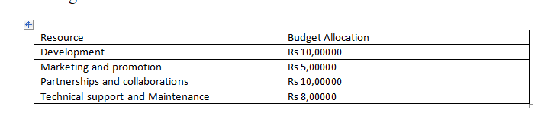

EcoHub's development and implementation require careful resource allocation and budgeting. The major areas that demand funding and the deployment of resources are broken down below:

## Development Costs:

* Software Development: Set aside money to hire qualified software engineers and developers to create and code the frontend and backend of the platform.
* Budget for hiring designers and UX experts to develop an easy-to-use and aesthetically pleasing interface for EcoHub.
* Infrastructure and Hosting: Set aside funds to support the creation and upkeep of the platform's servers, databases, and hosting services.
* Integration of APIs and Data Sources: To ensure accurate and current information, take into account the costs of integrating external APIs, data sources, and climate data providers.

## Marketing and Promotion:

* + - Digital marketing campaigns: Budget money for social media marketing, search engine optimisation, and targeted online advertising to attract consumers and raise awareness.
    - Partnership Collaborations: Set aside funds to develop alliances with educational institutions, sustainability influencers, and environmental organisations in order to broaden the platform's appeal.
    - Content Creation: Set aside money to produce informative, engaging content for EcoHub's website, such as blog articles, videos, and infographics.
    - Events and Workshops: Provide funding for the planning of events, workshops, and campaigns with a sustainability focus to promote EcoHub and boost user participation.

## Technical Support and Maintenance:

* + - Customer support: Set aside funds to form a specialised team to respond rapidly to user questions, technical problems, and feedback.
    - Platform Upkeep: Budget for regular upkeep, bug fixes, and updates to guarantee a seamless user experience and patch any security holes.
    - Data Backup and Security: Set aside funds for routine data backups, data security precautions, and adherence to applicable data protection laws.

## Human Resources:

* + - Project Management: Set aside funds for a project manager who will be in charge of EcoHub's creation, implementation, and upkeep.
    - Development Team: To ensure efficient development and deployment, provide funds for a team of knowledgeable developers, designers, and quality assurance experts.
    - Marketing and communication: Provide funds for content producers, social media experts, and marketing specialists to increase user interaction and advertise EcoHub.

## Partnerships and Collaborations:

* + - Financial Partnerships: Take into account looking for financial assistance from public or private organisations that share EcoHub's goals, such as government grants, business sponsorships, or impact investments.
    - In-kind Contributions: Look into potential for in-kind contributions, such as hosting services for servers, cloud computing resources, or data sources from technological partners and organisations that deal with climate change.

# Assessment of Potential Challenges and Plan for Overcoming Them:

We expect a number of difficulties as we adopt EcoHub. However, we can lessen their effects and guarantee the successful deployment of the digital solution by recognising these difficulties and proactively planning for them. Here are some potential obstacles we perceive and how we plan to overcome them:

## User Adoption and Engagement:

* + - Obstacle: Getting consumers to accept EcoHub and use the platform actively may be difficult.
    - Plan: Create a complete user engagement strategy that includes user involvement incentives, targeted marketing initiatives, and alliances with well-known sustainability advocates. Continue to collect user feedback to enhance the platform's features and usability, making sure it satisfies users' needs and preferences.

## Data Accuracy and Availability:

* + - Problem: Because data sources can differ in terms of trustworthiness and quality, it can be difficult to guarantee the accuracy and availability of climate data from outside sources.
    - Plan: Establish reliable data validation mechanisms in cooperation with reliable climate data sources. Take action to resolve data gaps and guarantee timely updates. Conduct routine quality checks and audits to preserve the accuracy of the data displayed on EcoHub.

## Technical Complexity and Scalability:

* + - Technically sophisticated platform development can be a challenge, especially in light of the integration of multiple features and the possible growth in user traffic.
    - Strategy: Design and build the platform's infrastructure with the help of skilled software developers and architects, assuring scalability and performance improvement. Debug and test everything thoroughly to find and fix technical problems. Maintain a constant eye on the platform's infrastructure and make any necessary upgrades to meet rising user needs.

## Funding and Sustainability:

* + - Challenge: Finding sufficient funds to sustain the creation, upkeep, and growth of EcoHub might be difficult.
    - Plan: Create a varied funding strategy that includes sponsorships, collaborations, grants, and prospective revenue streams like premium features or alliances with environmentally conscious companies. To draw in and keep financial backers, you should constantly look for funding opportunities and keep your financial reporting open.

## Privacy and Data Security:

* + - Problem: Ensuring strong data security and protecting user privacy can be a major worry.
    - Make a plan and put rigorous data protection measures in place, such as encryption, secure storage, and adherence to applicable privacy laws. To find and fix vulnerabilities, conduct routine security audits and work with cybersecurity professionals. Users should be made aware of the platform's privacy regulations, and data collection and use requires their explicit consent.

## Collaboration and Partnerships:

* + - Difficulty: Aligning objectives, allocating resources, and coordinating efforts may be problems when establishing and maintaining partnerships with environmental organisations, companies, and academic institutions.
    - Plan: Clearly specify the shared objectives and reciprocal advantages of cooperative partnerships. Create effective communication lines, hold regular meetings, and keep decision-making procedures open.

# Conclusion:

In order to solve the worldwide challenge of climate change, the creation and implementation of EcoHub as a digital solution for climate change mitigation offer enormous promise. EcoHub helps people and organisations to take meaningful action towards lowering their carbon emissions and implementing sustainable practises by integrating elements like carbon footprint computation, personalised action plans, community interaction, and resource libraries.

To measure the impact of EcoHub, several key metrics can be considered:

* Carbon Emission Reduction: Analyse users' carbon footprint calculations and follow their development over time to assess the overall carbon emission reduction made by EcoHub users. This information will shed light on how well the platform works to alter behaviour and lower carbon emissions.
* User Engagement and Adoption: Track the number of users who are active, how often they interact, and how much they participate in the sustainability activities that EcoHub supports. This indicator will show how well the platform can motivate and engage users to pursue long-term climate action.
* Knowledge Dissemination and Resource Utilisation: Examine the extent to which users access and make use of the EcoHub-provided case studies, research articles, and teaching materials. This assessment will examine how well the platform works to spread knowledge and encourage wise decision-making.
* Collaborative efforts and Partnerships: Assess the development and influence of cooperative efforts supported by EcoHub, including partnerships, projects, and groups with a sustainability focus. This evaluation will focus on the platform's capacity to promote cooperation and mobilise group action for climate change mitigation.
* User input and Satisfaction: To review user experiences, find areas for development, and make sure the platform fulfils user expectations, continuously collect user input and conduct satisfaction surveys.

# Key Takeaways from this Assignment:

This assignment on investigating digital climate change solutions has given us insightful knowledge about the potential of technology to solve problems in the real world. Through our investigation and development of EcoHub, we have come to understand the significance of combining digital technology, teamwork, and user involvement.

Key takeaways from this assignment include:

* Through the provision of creative solutions, the promotion of collaboration, and the empowerment of people and organisations to take meaningful action, digital technology provides enormous potential in combating climate change.
* User acceptance and engagement with digital solutions are essential to their success. We can develop and deploy platforms that resonate with users and promote positive change by comprehending user needs, preferences, and behaviour.
* Collaborations and partnerships are important for increasing the effect of digital solutions. We may pool resources, knowledge, and skills by working with a variety of stakeholders to develop a more complete and robust solution.
* For digital solutions to be effective and sustainable over the long term, ongoing monitoring, evaluation, and improvement are crucial. The solution stays relevant and effective by adapting to user feedback, new technology, and changing conditions.

In conclusion, research into digital climate change solutions has shown the transformative power of technology in solving global problems. We can leverage the power of digital technology to create a more resilient and sustainable future by embracing innovation, cooperation, and user-centric design.

# Bibliography

Asana. (2020, may 15). *What is an implementation plan*. Retrieved from https://asana.com/resources/implementation-plan.

Issues, G. (2010). *Global Issues*. Retrieved from https://www.un.org/en/global-issues/climate-change.

Jackson, S. T. (2023). *climate change*. Retrieved from https://www.britannica.com/science/climate-change.

# Appendices:

Floor chart:

